Let's Meet

Group ID: 05

3005 – Jaishil Bhavsar

3036 – Zeel Modi

3186 – Bhargavi Jansari

**Index**

**Chapter 4: System Analysis and Design1**

4.1 UML (Unified Modeling Language)3

4.2 System Flow Diagram3

4.3 Data Dictionary4

4.4 User Interface4

4.5 System Navigation4

# [**4.1**] UML (Unified Modeling Language)

# [**4.4.1**] Use Case

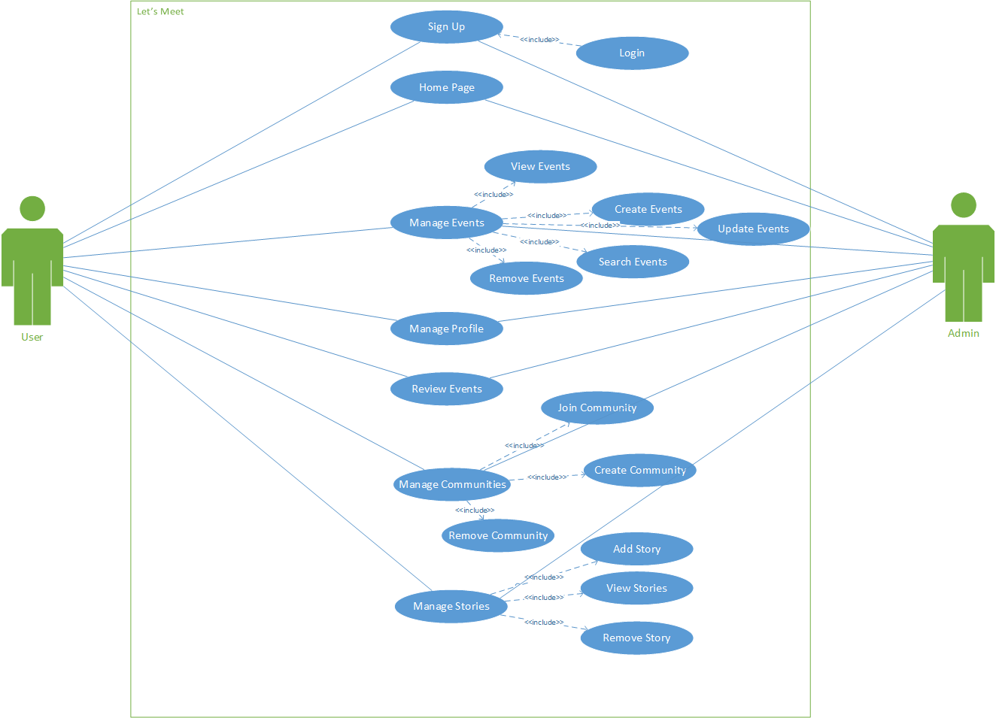

( fig 4.1 – Use Case of System)

# [**4.4.2**] Class Diagram

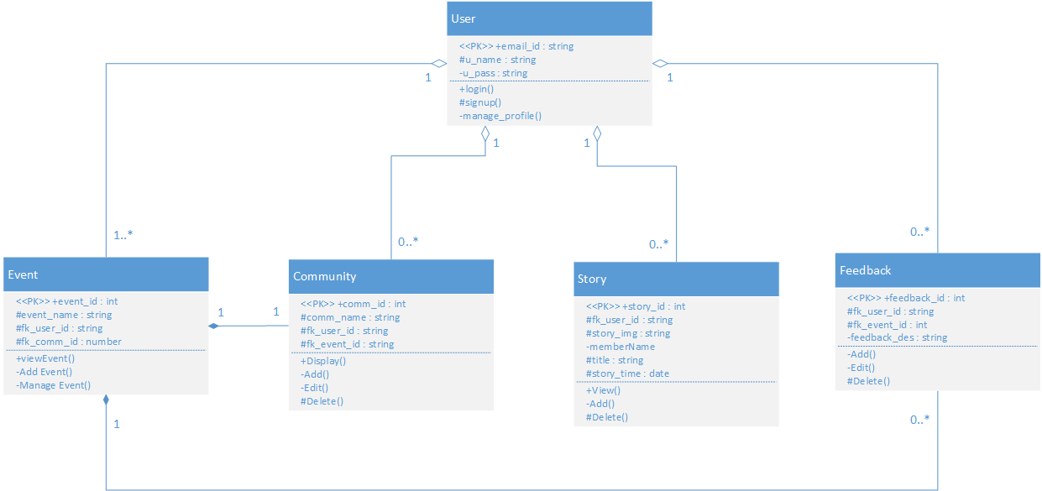

# [**4.2**] System Flow Diagram

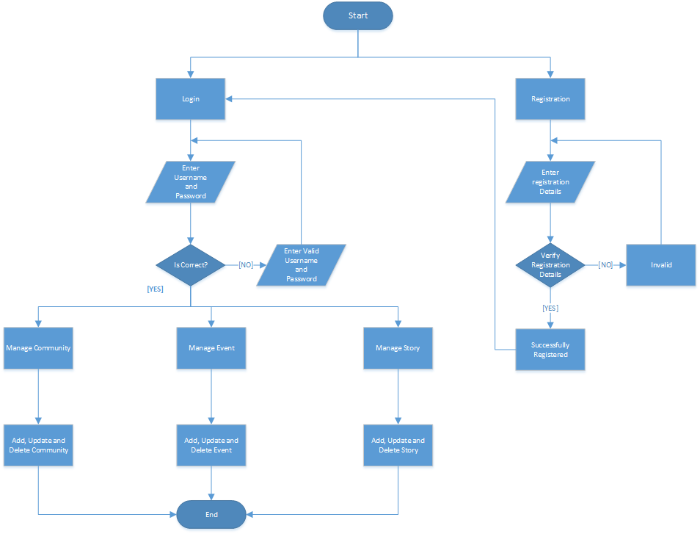

# [**4.3**] Data Dictionary

Users

|  |  |  |  |  |
| --- | --- | --- | --- | --- |
| Field | Data-Type | Constrains | Remarks | Description |
| User_id | Varchar(30) | Primary Key | - | User’s email id. |
| User_name | Varchar(20) | Not Null | - | Display User’s Name |
| User_photo | Varchar(500) | - | - | Display Picture |
| Gender | Varchar(6) | - | - | User’s Gender |
| Password | Varchar(10) | Not Null | - | Password for Login |
| Mobile_no | Varchar(15) | - |  | User’s Mobile No |
| Birth_date | Date | - | - | User’s Birth Date |
| Fk_com_id | Integer | Foreign Key | - | Under which Communities |

Communities

|  |  |  |  |  |
| --- | --- | --- | --- | --- |
| Field | Data-Type | Constrains | Remarks | Description |
| Comm_id | Integer | Primary Key | Auto-Increment | Community id |
| Comm_name | Varchar(20) | Not Null | - | Community Name |
| Comm_des | Varchar(300) | Not Null | - | Describe the community |
| Comm_photo | Varchar(500) | - | - | Community Picture |
| Date | Date | Not Null | - | Date created |
| Fk_user_id | Varchar(50) | Foreign Key | - | Users joined Community |
| Fk_post_id | Integer | Foreign Key | - | Posts in Community |
| Fk_event_id | Integer | Foreign Key | - | Events of Community |
| Comm_rating | Integer |  | - | Rating of Community |

Events

|  |  |  |  |  |
| --- | --- | --- | --- | --- |
| Field | Data-Type | Constrains | Remarks | Description |
| Event_id | Integer | Primary Key | Auto-Increment | Event’s Id |
| Event_name | Varchar(100) | Not Null | - | Event’s Name |
| Event_pic | Varchar(500) | - | - | Event Photo |
| Event_des | Varchar(500) | - | - | Event Description |
| Event_time | Varchar(20) | - | - | Event Time |
| Event_date | Date | Not Null | - | Event Date |
| Event_loc | Varchar(100) |  | - | Event Venue |
| Fk_user_id | Varchar(50) | Foreign Key | - | Who Created? |
| Fk_comm_id | Integer | Foreign Key | - | Under Which Community? |

Story

|  |  |  |  |  |
| --- | --- | --- | --- | --- |
| Field | Data-Type | Constrains | Remarks | Description |
| Story_id | Integer | Primary Key | Auto-Increment | Story id |
| Story_pic | Varchar(500) | Not Null | - | Story Photo |
| Fk_user_id | Varchar(50) | Foreign Key | - | Who Posted? |
| Story_title | Varchar(100) | Not Null | - | Story Caption |
| Story_time | Date | Not Null | - | When Story Posted? |

Follower

|  |  |  |  |  |
| --- | --- | --- | --- | --- |
| Field | Data-Type | Constrains | Remarks | Description |
| Follo_id | Integer | Primary Key | Auto-Increment | Follower Id |
| Fk_user_id | Varchar(50) | Foreign Key | - | User being followed |
| Fk_us_id | Varchar(50) | Foreign Key | - | Who Followed? |

Community Members

|  |  |  |  |  |
| --- | --- | --- | --- | --- |
| Field | Data-Type | Constrains | Remarks | Description |
| Join_id | Integer | Primary Key | Auto-Increment | Community join Id |
| Fk_user_id | Varchar(50) | Foreign Key | - | User who joined community |
| Fk_comm_id | Integer | Foreign Key | - | Which community did user joined |

Feedbacks

|  |  |  |  |  |
| --- | --- | --- | --- | --- |
| Field | Data-Type | Constrains | Remarks | Description |
| Feed_id | Integer | Primary Key | Auto-Increment | Feedback id |
| Fk_event_id | Integer | Foreign Key | - | Under which Event |
| Fk_user_id | Varchar(50) | Foreign Key | - | Who gave feedback? |
| Feed_desc | Varchar(200) | Not Null | - | Feedback Description. |

Posts

|  |  |  |  |  |
| --- | --- | --- | --- | --- |
| Field | Data-Type | Constrains | Remarks | Description |
| Post_id | Integer | Primary Key | Auto-Increment | Post Id |
| Post_title | Varchar(30) | Not Null | - | Caption |
| Post_des | Varchar(200) | - | - | Describe the Post |
| Post_pic | Varchar(500) | - | - | Photo in Post |
| Fk_user_id | Varchar(50) | Foreign Key | - | User who posted this Post |
| Fk_comm_id | Integer | Foreign Key | - | Under which Community |
| Date | Date | Not Null | - | Date Created Post. |

Likes

|  |  |  |  |  |
| --- | --- | --- | --- | --- |
| Field | Data-Type | Constrains | Remarks | Description |
| Like_id | Integer | Primary Key | Auto-Increment | Like id |
| Fk_post_id | Integer | Foreign Key | - | Under which Post |
| Fk_user_id | Varchar(50) | Foreign Key | - | Who liked? |

Comments

|  |  |  |  |  |
| --- | --- | --- | --- | --- |
| Field | Data-Type | Constrains | Remarks | Description |
| Com_Id | Integer | Primary Key | Auto-Increment | Comment id |
| Fk_post_id | Integer | Foreign Key | - | Under which post |
| Fk_user_id | Varchar(50) | Foreign Key | - | Who commented? |
| Date | Date | Not Null | - | Date Created |
| Com_des | Varchar(300) | Not Null | - | Content of Comment |

RSVP

|  |  |  |  |  |
| --- | --- | --- | --- | --- |
| Field | Data-Type | Constrains | Remarks | Description |
| Rsvp_id | Integer | Primary Key | Auto-Increment | RSVP id |
| Fk_user_id | Varchar(50) | Foreign Key | - | Users attending event |
| Fk_event_id | Varchar(50) | Foreign Key | - | Which event user is going to attend? |

Polls

|  |  |  |  |  |
| --- | --- | --- | --- | --- |
| Field | Data-Type | Constrains | Remarks | Description |
| Poll_id | Integer | Primary Key | Auto-Increment | Poll Id |
| Poll_title | Varchar(100) | Not Null | - | Tag line of Poll |
| Option1 | Varchar(50) | Not Null | - | First opinion of poll |
| Option2 | Varchar(50) | Not Null | - | Second opinion of Poll |
| Option3 | Varchar(50) | - | - | Third opinion of Poll |
| Option4 | Varchar(50) | - | - | Fourth opinion of Poll |
| Fk_user_id | Varchar(50) | Not Null | - | Who Created? |
| Fk_comm_id | Integer | Not Null | - | Under Which Community? |

Categories

|  |  |  |  |  |
| --- | --- | --- | --- | --- |
| Field | Data-Type | Constrains | Remarks | Description |
| Cat_id | Integer | Primary Key | Auto-Increment | Category Id |
| Cat_name | Varchar(20) | Not Nulll | - | Category Name |

# [**4.4**] User Interface

# [**4.5**] System Navigation